**Guidelines for Data Visualization and Analysis Project**

**About the Project:**

In this project, you will be working with a dataset from the Superstore, aiming to answer 30 scenario-based questions through data visualization and analysis. Your objective is to select the best chart for each question, explain your choice. This project will showcase your proficiency in data visualization, critical thinking, and effective communication.

**Skills Required:**

* Proficiency in data visualization concepts and techniques.
* Familiarity with Tableau or a similar data visualization tool.
* Strong analytical and problem-solving skills.
* Ability to choose appropriate charts based on data characteristics and question requirements.
* Clear and concise communication skills.

**Deliverables:**

* A Google document containing solutions to the scenario based questions including the screenshot of relevant chart picked for each scenario, presented in a concise and well-structured format. Make sure to provide explanations that highlight your problem-solving skills.

**Rubrics for Assessment:**

Question Responses:

* Accuracy and completeness of answers for all 30 questions.
* Clear and concise explanations that address the question's context.

Chart Selection and Explanation:

* Thoughtful rationale for choosing specific chart types.
* Justification based on data characteristics, context, and communication goals.

Creative Enhancements:

* Effective use of creative elements to enhance visualization quality.
* Enhancements that contribute to better understanding or engagement.

**Note**:

* Duplicate this document and proceed to write your solutions.
* For each scenario and question, provide a justification for the choice of chart type. Explain why it is the best option to visualize the data effectively.
* Attach screenshots of the charts you have created in Tableau for each scenario and question using the Superstore dataset. Label them clearly to match the corresponding questions in the Google Document.
* Submit the duplicated google doc file after completion.

Use these guidelines to structure your data visualization and analysis project. Remember to maintain consistency in your responses, explanations, and visualization styles. This project will not only demonstrate your skills but also your ability to effectively communicate complex information through visualizations. Good luck!

**Problem Statement: Choose the Best chart for any 30 scenario based questions from Superstore Dataset.**

Imagine you are a data enthusiast aiming to excel in data visualization and analysis. In this task, you have been given any 30 scenario-based questions derived from the Superstore dataset, and your objective is to provide insightful answers using appropriate charts. For each question, you need to select a chart that best represents the data, explain why you chose that specific chart, and then proceed to build the chosen chart using Tableau.

Your responses should be succinct, organized, and illustrative of your problem-solving capabilities.

**Dataset Link:**

<https://community.tableau.com/s/question/0D54T00000CWeX8SAL/sample-superstore-sales-excelxls>

**Please keep in mind:**

1. **Answer Completion**: Ensure that you furnish answers for all any 30 questions and build charts for them.
2. **Encouraged Creativity**: Don't hesitate to employ visuals, creative elements, or any other innovative approaches to enhance the quality of your responses.

By completing this task effectively, you'll not only demonstrate your proficiency in data visualization and analysis but also showcase your ability to effectively communicate complex concepts through both text and charts.

**Good luck!**

**Questions:**

1. Which product categories have the highest total sales in the "Superstore" dataset?

Ans: A bar chart is a suitable choice for visualizing the total sales by product categories.

Bar charts are effective for comparing the total sales across different product categories. Each bar represents a category, making it easy to see the relative sizes of the sales figures. Bar charts are simple and intuitive, making them accessible to a wide audience. They are easy to understand, even for individuals who may not be familiar with complex data visualizations.

Bar charts can be easily customized to include additional information, such as labels for each bar, tooltips, or colour-coded bars for better distinction. This flexibility allows you to enhance the chart for better communication of insights. Bar charts naturally represent aggregated data by displaying the sum of sales for each category.

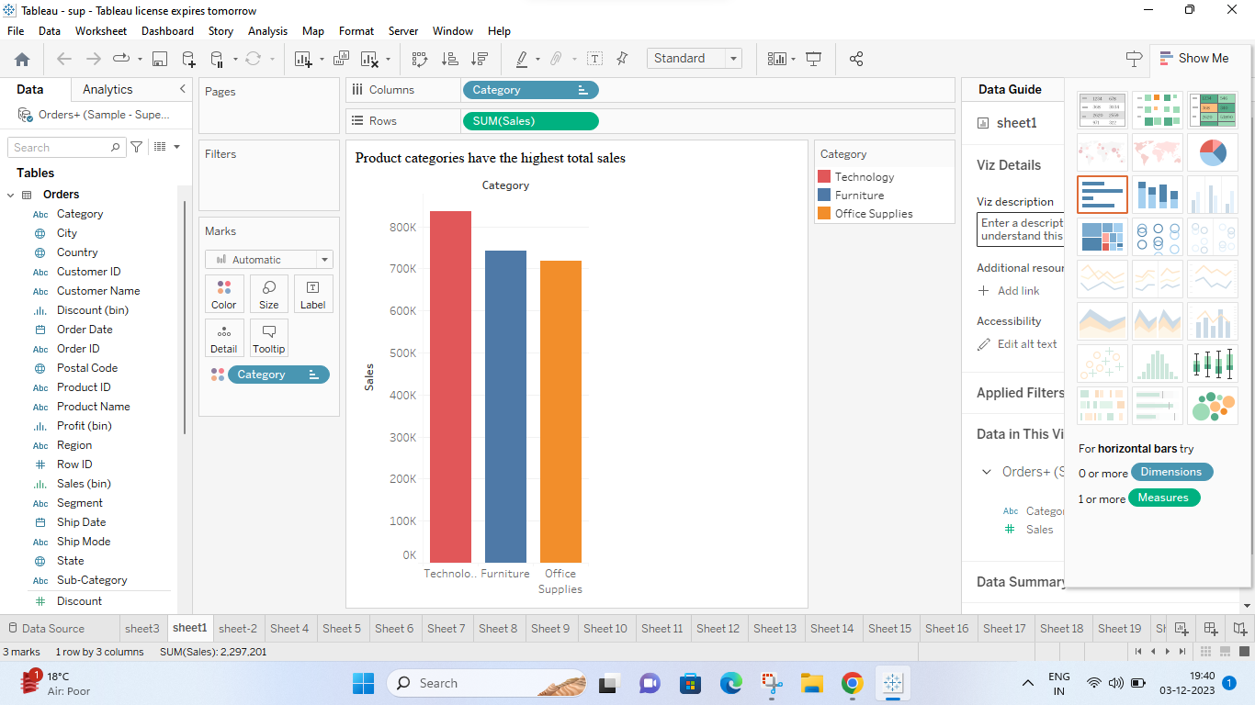

1. How do the monthly sales amounts change over the course of a year?

Ans: A line chart is particularly effective for visualizing how a numerical variable (in these case, monthly sales) changes over time. The sequential nature of the line chart is suitable for representing the monthly sales amounts in chronological order. Each point on the line corresponds to a specific month, creating a smooth representation of the sales progression. The lines connecting consecutive points help emphasise the continuity and flow of the data. Data for multiple years, using different colours or lines for each year allows for easy comparison of sales patterns between different time periods.Line charts provide a clear and concise representation of trends, making it easy to identify periods of growth, decline, or seasonality.

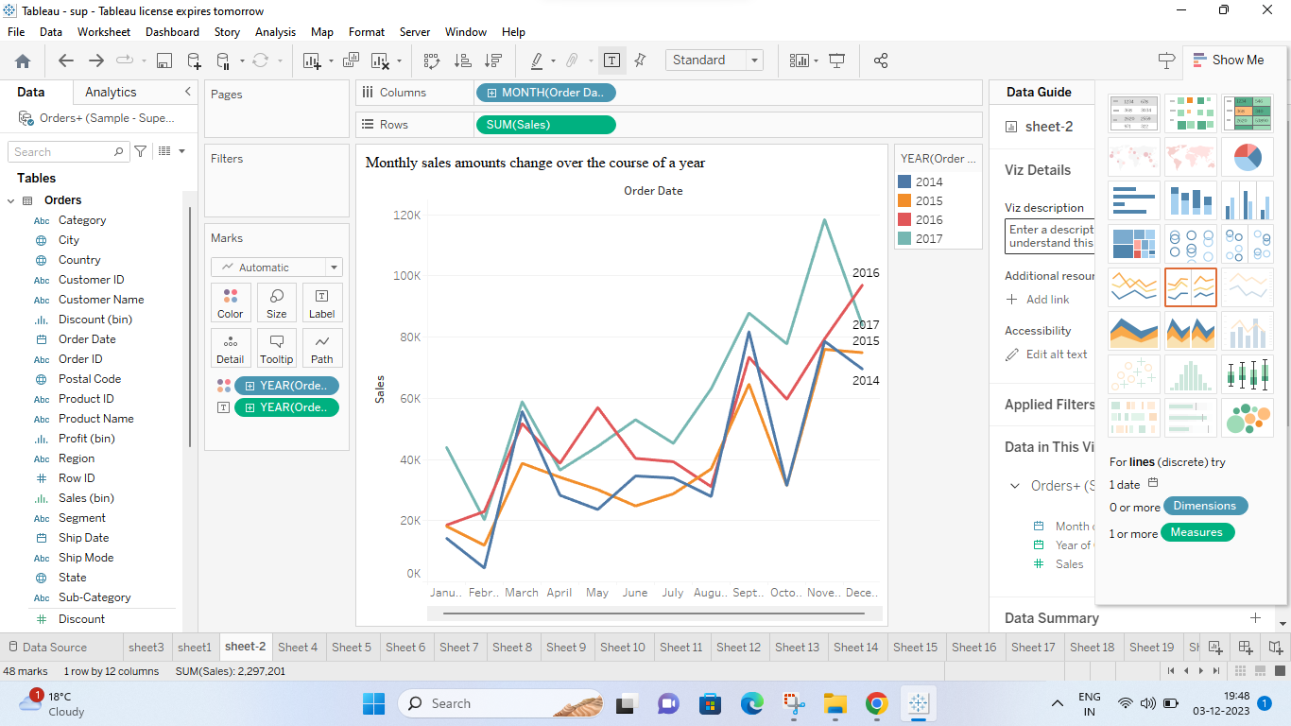

1. How is the total sales amount distributed among different product categories?

Ans: Pie charts are effective when we want to emphasize the proportions of different categories relative to the whole (total sales). Each slice represents a category, and the size of the slice reflects its contribution to the total sales. Pie charts are simple and easy to understand, making them suitable for conveying a high-level overview of the distribution without overwhelming the viewer with complex details. Pie charts work best when you have a small number of categories.

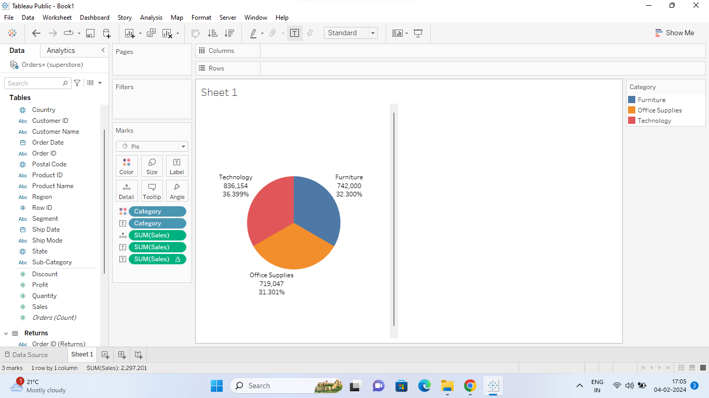

1. Can we analyze the sales performance of individual customers over time?

Ans:A horizontal chart allows us to compare the sales performance of individual customers side by side. Each customer's sales performance is represented as a horizontal bar, making it easy to compare their performance relative to one another. Horizontal charts are particularly useful when dealing with a large number of individual customers. This allows for detailed analysis of each customer's behavior and performance, which may be valuable for identifying loyal customers, detecting changes in purchasing patterns, or targeting specific customers for retention efforts. Overall, using a horizontal chart in Tableau to analyze the sales performance of individual customers over time provides a clear and efficient way to compare and explore customer behavior, identify trends, and make data-driven decisions to optimize sales strategies and enhance customer relationships.

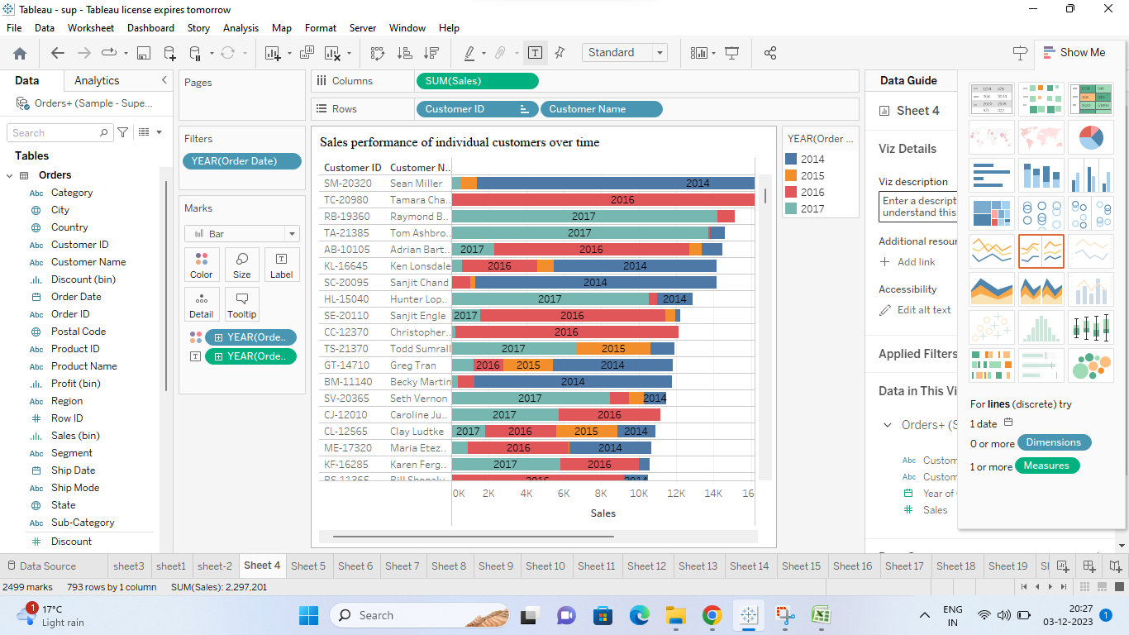

1. How do sales vary based on different days of the week and product categories?

Ans: An area chart is effective for comparing how sales vary across different product categories on different days of the week. Each area represents a product category, and the height of the area at each day indicates the sales for that combination. The stacked nature of the area chart allows to see the overall sales while also understanding the contribution of each product category to the total sales.

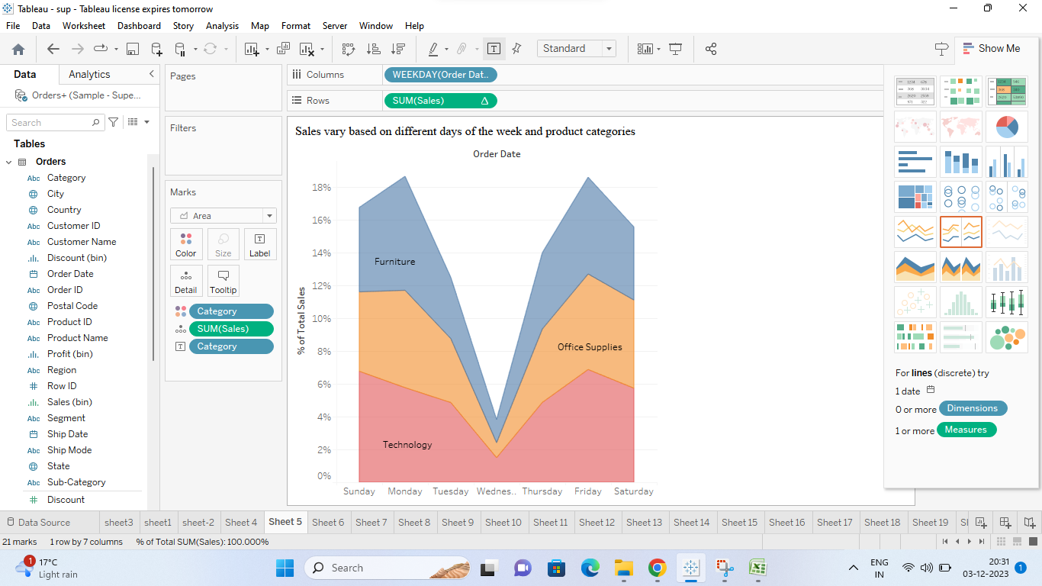

1. Can we visualize the sales growth of different product categories over time?

Ans: A line chart is effective for visualizing the sales growth of different product categories over time. Each line in the chart represents a product category, making it easy to compare the sales growth trajectories of different categories. Line charts provide a clear and concise representation of trends, making it easy to identify periods of growth, decline, or stability in sales for each category.

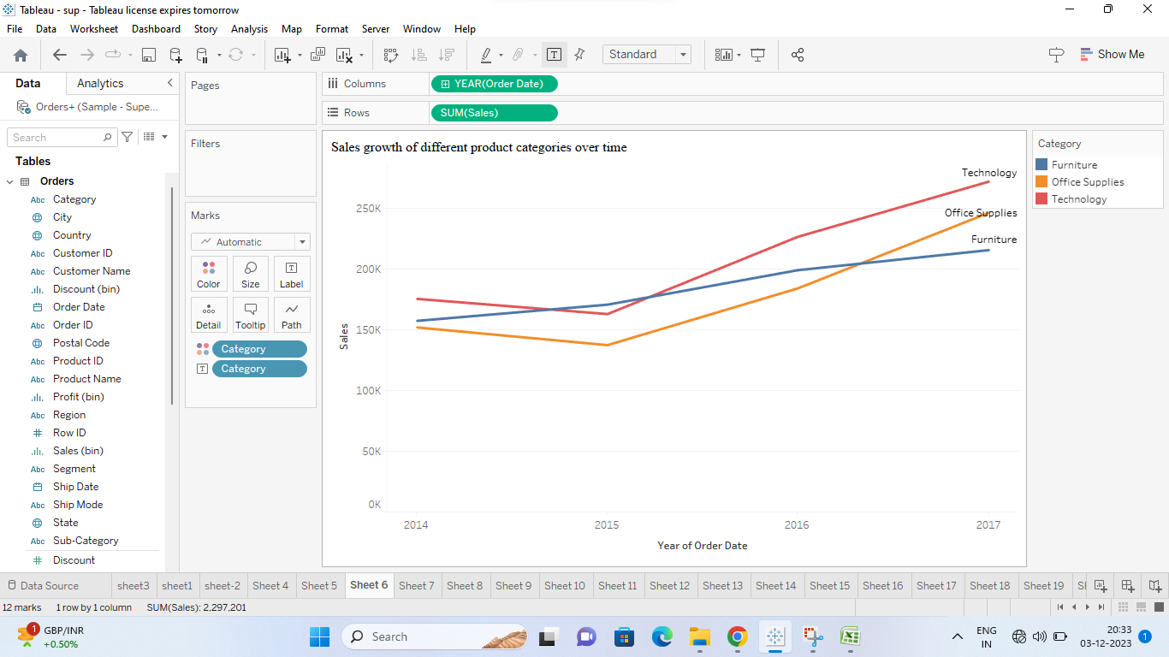

1. How does the sales distribution vary across different regions in the "Superstore" dataset?

Ans: A column chart is effective for comparing the sales distribution across different regions. Each column represents a region, making it easy to compare the heights of the columns to identify which regions have higher or lower sales.

Regions are categorical data, and column charts are well-suited for representing the distribution of values within categories. Each column corresponds to a specific region. Column charts are straightforward and easy to interpret, making them accessible to a wide audience.

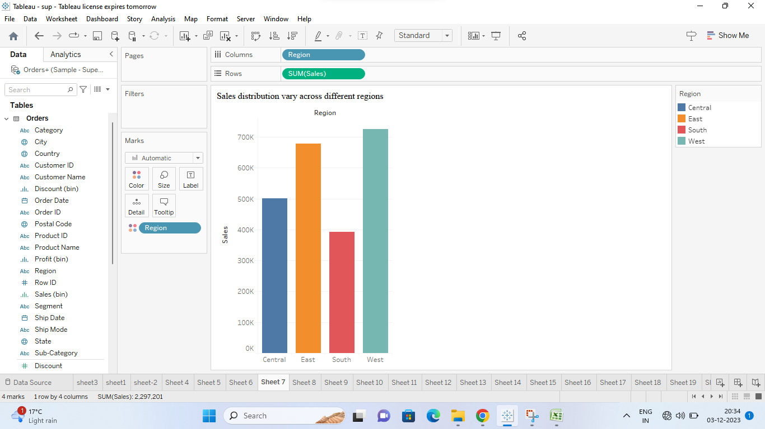

1. Can we visualize the composition of profits across various subcategories within different customer segments?

Ans: Tree maps are effective for representing hierarchical structures, making them suitable for visualizing the composition of profits across different customer segments and subcategories. In a tree map, the size of each rectangle represents the magnitude of profits. Viewers can quickly compare the sizes of rectangles to identify areas with higher or lower profits. Tree maps allow for nesting of rectangles within larger rectangles, providing a clear visual hierarchy. Customizing colors in a tree map helps in differentiating between customer segments or subcategories. Tree maps are space-efficient and can represent a large amount of data in a compact form. This is especially useful when dealing with multiple subcategories and customer segments. Tree maps in Tableau are interactive, allowing users to explore the data dynamically by adjusting filters or selecting specific segments for a more detailed analysis.

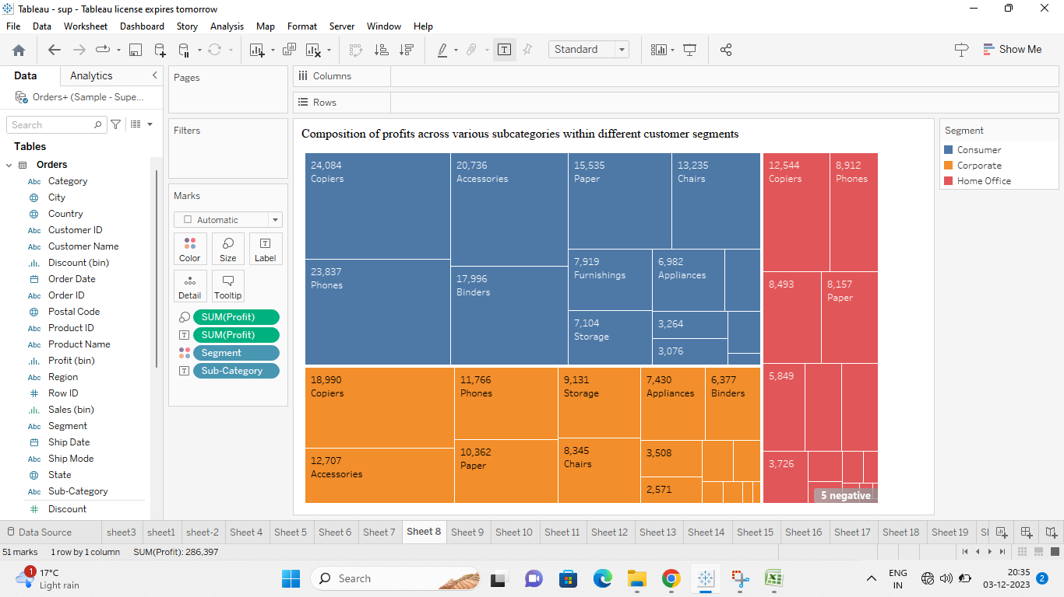

1. What is the percentage contribution of each region to the overall sales?

Ans: Pie charts are suitable for displaying the percentage contribution of different categories (regions, in this case) to a whole (total sales). Each slice represents a region, and the size of the slice is proportional to the percentage of total sales that the region contributes. Pie charts are simple and easy to understand. They provide a quick visual overview of the distribution of sales among regions without requiring a complex analysis. Pie charts are space-efficient and can effectively convey the distribution of sales in a single view. This is particularly useful when dealing with a small number of categories, such as regions.

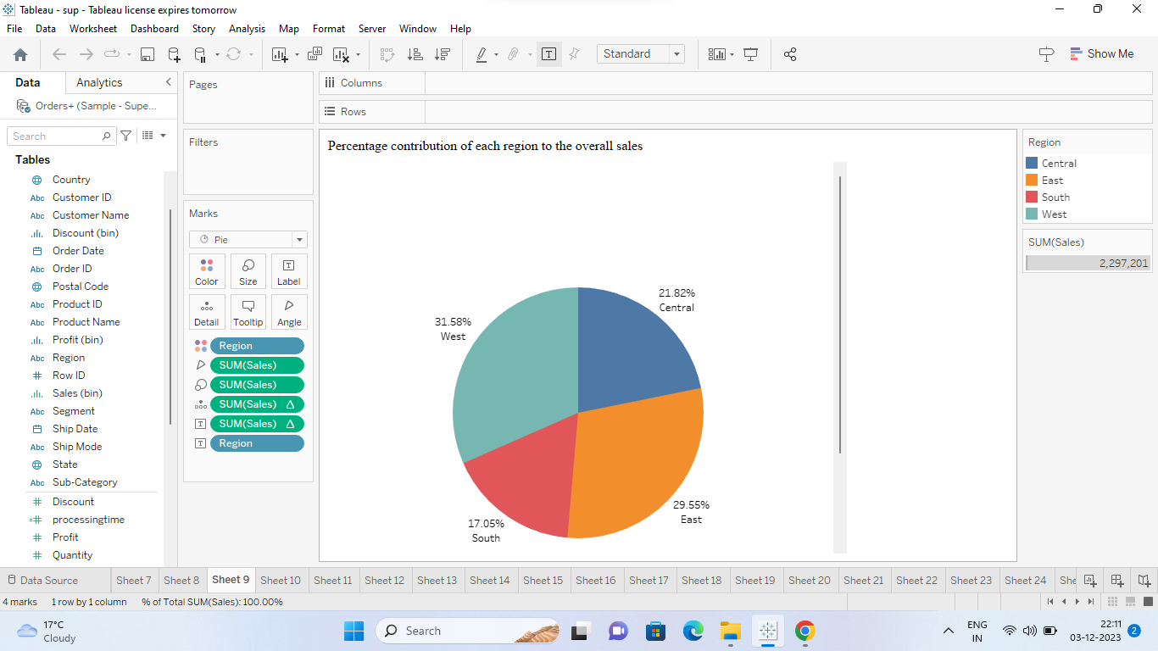

1. Can we visualize the profit margins associated with different shipping modes and customer segments?

Ans: A grouped bar chart separates the bars for different customer segments, and within each bar, there are grouped bars representing different shipping modes. This allows for a clear comparison of profit margins between shipping modes and within each mode, the impact of different customer segments.

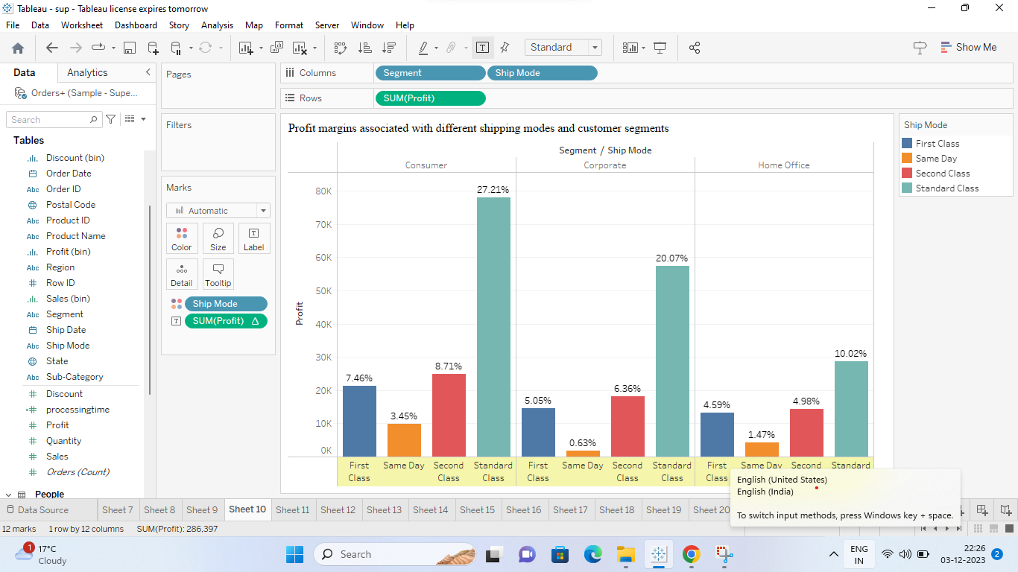

1. How long does it take to process orders for different product categories?

Ans: Gantt charts are designed for representing the duration of activities over time. In this case, the processing time of orders for different product categories can be easily understood using the length of the bars. Gantt charts allow for a straightforward comparison of the processing times for different product categories. Users can quickly identify which categories have longer or shorter processing times. Product categories are displayed sequentially along the y-axis, and the length of each bar represents the time it takes to process orders in that category. This sequential representation is beneficial for understanding the order of processing times. Gantt charts are space-efficient and can effectively display a large amount of time-related data in a compact form.

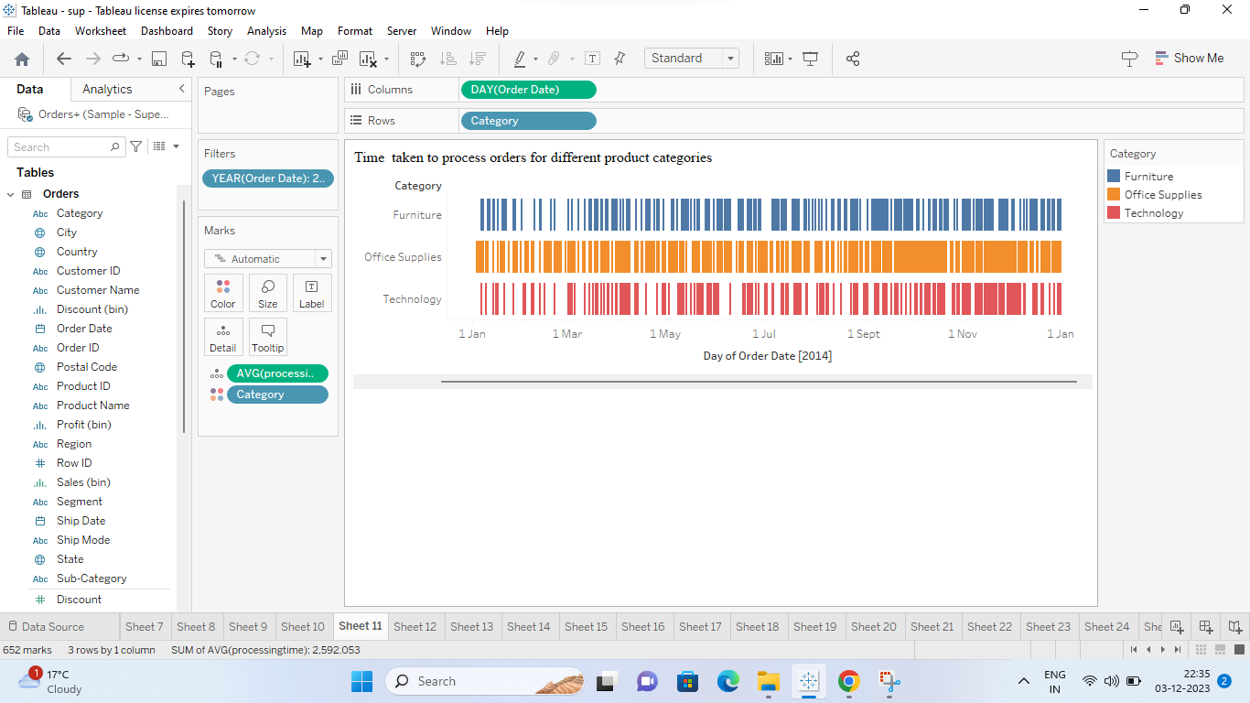

1. How does the performance of different salespeople compare in terms of actual sales, and profitability?

Ans: Grouped bar charts are well-suited for comparing multiple metrics (in this case, actual sales and profitability) for each category (salesperson). The side-by-side bars make it easy to see how each salesperson performs in both aspects. The grouped structure allows viewers to identify trends and patterns within each salesperson's performance. For example, it's easy to see if a salesperson with high sales also has high profitability. Grouped bar charts provide a clear differentiation between different metrics and categories, avoiding confusion and facilitating quick insights into the performance variations among salespeople.

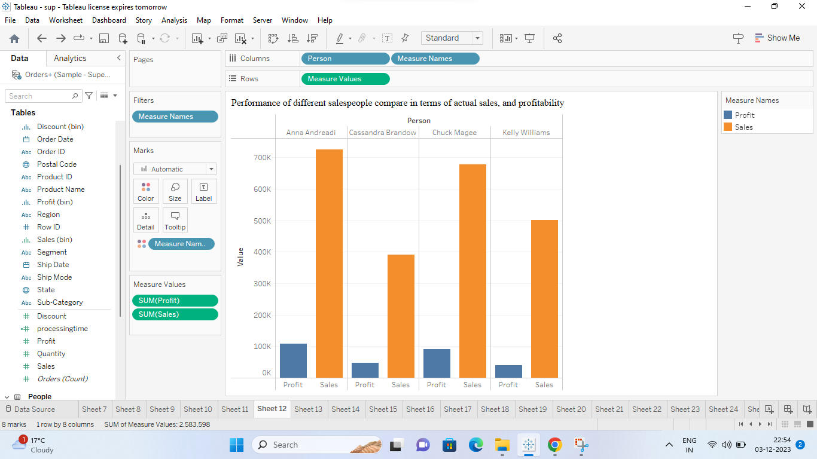

1. Can we visualize the relationship between product sales and profitability for different product categories?

Ans: Grouped bar charts allow for easy comparison of multiple variables (in this case, product sales and profitability) across different categories (product categories). Each product category can have two bars side by side, one representing sales and the other representing profitability, making it simple for viewers to compare the two metrics within each category. The grouped bars provide a clear visual representation of the relationship between product sales and profitability. Viewers can easily see how sales and profitability vary across different product categories and identify any patterns or trends. Grouped bar charts efficiently use space on the visualization canvas by grouping related bars together. This makes it easy to compare sales and profitability for multiple product categories without cluttering the chart or overwhelming the viewer. By visualizing sales and profitability using a grouped bar chart, you can gain insights into which product categories are driving the most sales, as well as which categories are the most profitable. This information can be valuable for making strategic decisions, such as allocating resources to high-performing product categories or identifying opportunities to improve profitability in underperforming categories.

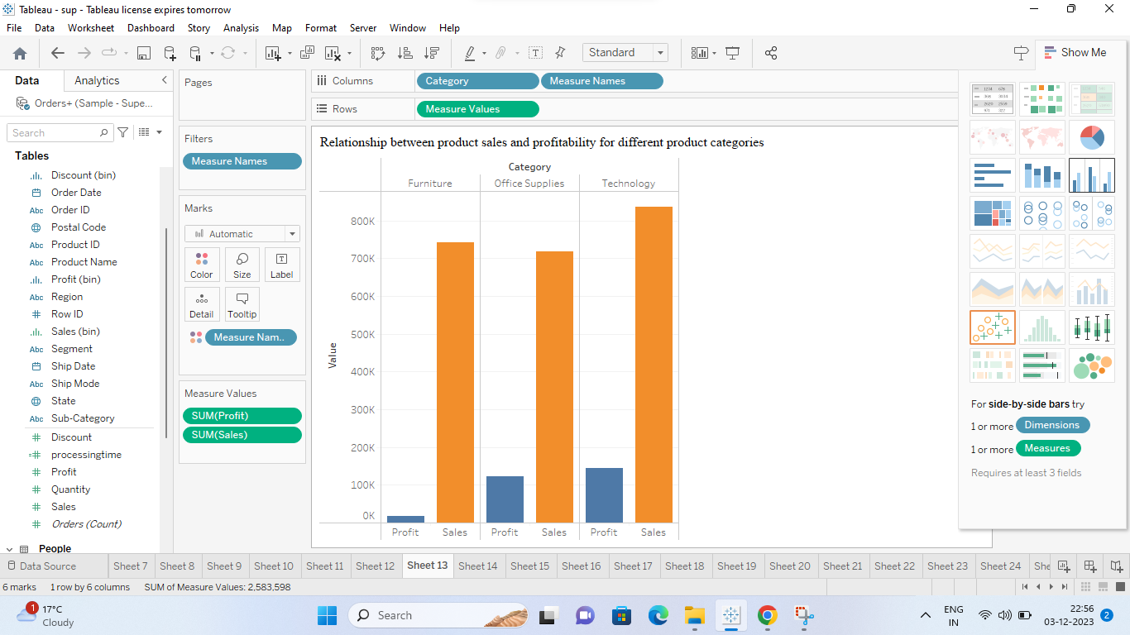

1. What is the distribution of order quantities for products in the dataset?

Ans: A horizontal bar chart is effective for visualizing the distribution of order quantities for different products. Each bar represents a product, and the length of the bar corresponds to the order quantity. Order quantities are quantitative data, and bar charts are well-suited for representing the magnitude of values within categories (products).Bar charts are often space-efficient and can effectively display the distribution of values for multiple products.Users can easily compare the lengths of bars to identify which products have higher or lower order quantities.

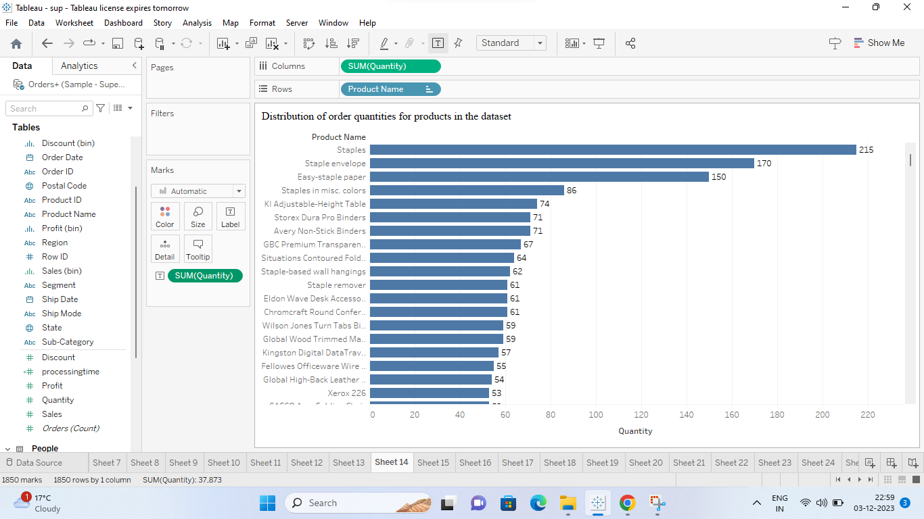

1. How do the profit distributions vary across different product categories?

Ans: Pie charts are suitable when we want to show the proportional contribution of each category (product category) to the whole (total profits).Pie charts are more effective when dealing with a small number of categories. Pie charts provide a summarized view of the distribution, making it easy to identify which product categories contribute more or less to the total profits. Pie charts are easy to understand at a glance and are accessible to a wide audience.

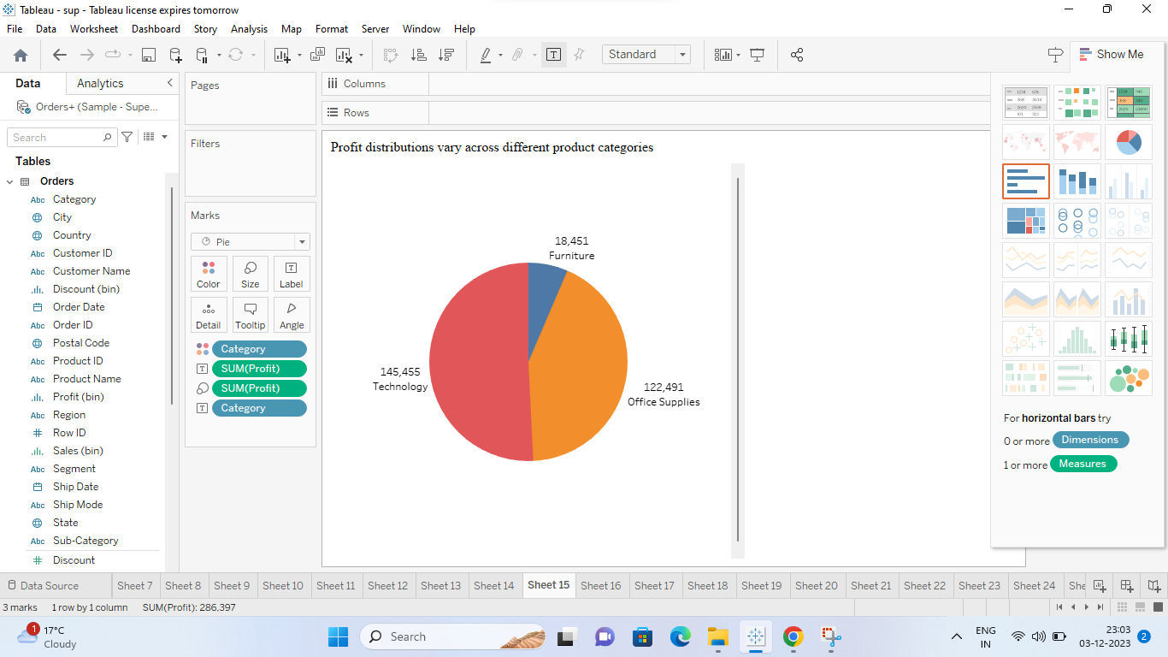

1. Can we compare the shipping time distributions for different shipping modes?

Ans: A column chart is effective for comparing shipping times for different shipping modes. Columns are arranged sequentially along the x-axis, allowing for a clear representation of how shipping times vary for different shipping modes. The visual distinction between columns emphasizes differences in shipping times, aiding in the comparison of shipping modes.

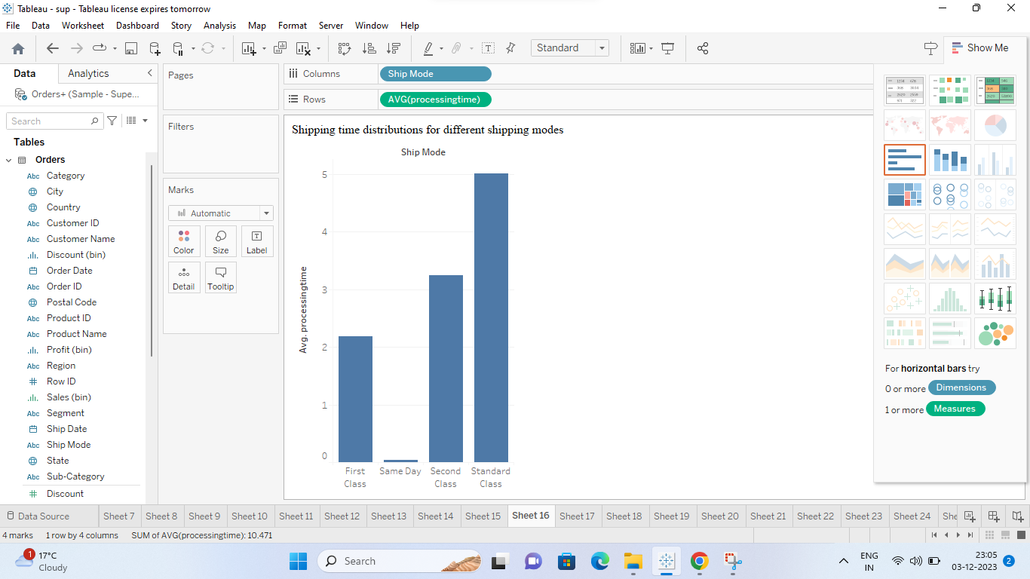

1. What is the monthly trend in the number of orders shipped?

Ans: Line charts are particularly effective for representing data trends over time. A line chart can easily display how the number of orders changes from month to month.Line charts is suitable for displaying sequential data, where one data point follows another in a logical order. The months are sequential, and a line chart will naturally connect data points in the order of time. Line charts provide a clear visual representation of trends and patterns. They help in identifying upward or downward trends in the number of orders over the months, making it easy for viewers to interpret and understand the data.

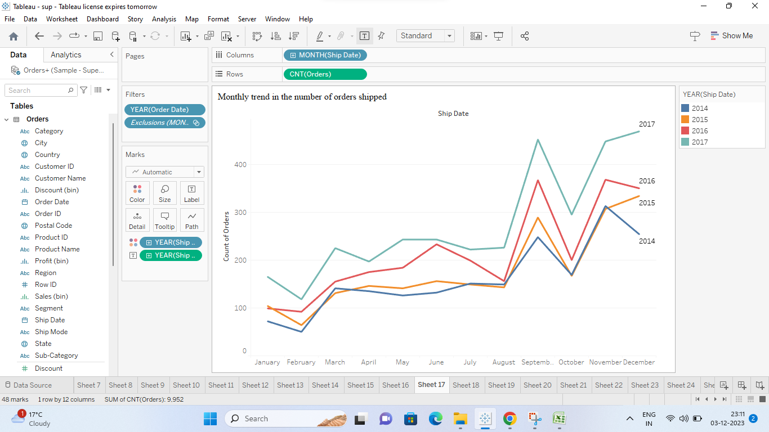

1. How do different customer segments perform in terms of sales and discount rates?

Ans: Scatter plots provide a clear and intuitive way to visualize the relationship between two variables (sales and discount rates) for multiple categories (customer segments). Each data point represents a specific customer segment, making it easy to compare their performance at a glance.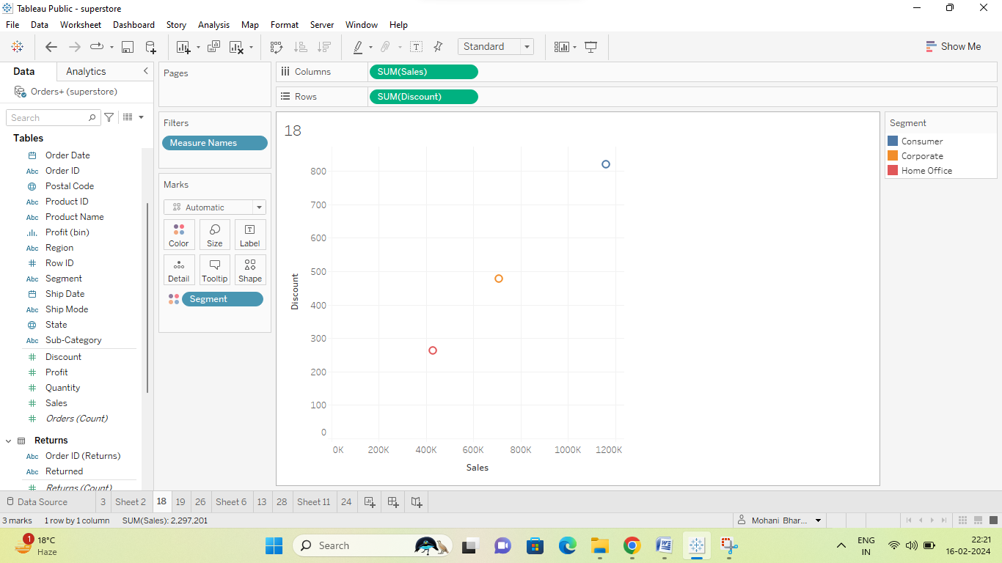

1. What are the sales and profit trends across different product subcategories and regions in the Superstore dataset?

Ans: Scatter plots allow for the comparison of two variables (sales and profit) across different categories (product subcategories and regions) simultaneously. Each point on the plot represents a combination of sales and profit for a specific subcategory and region, enabling viewers to easily identify trends and patterns. Scatter plots are ideal for visualizing the relationship between two continuous variables, such as sales and profit. Dual axes allow to display two different measures (sales and profit) with different scales on the same plot. This is important because sales and profit may have different magnitudes, and displaying them on separate axes prevents one measure from dominating the visualization and obscuring trends in the other. Scatter plots facilitate the identification of trends, outliers, and correlations between sales and profit across different product subcategories and regions. This can help analysts uncover insights such as which subcategories are most profitable in which regions, or how sales performance varies across different regions. Tableau allows for interactivity in visualizations, such as tooltips and filters. With a scatter plot, viewers can interactively explore sales and profit data by hovering over points to see specific values or using filters to focus on specific subcategories or regions, enhancing the depth of analysis.

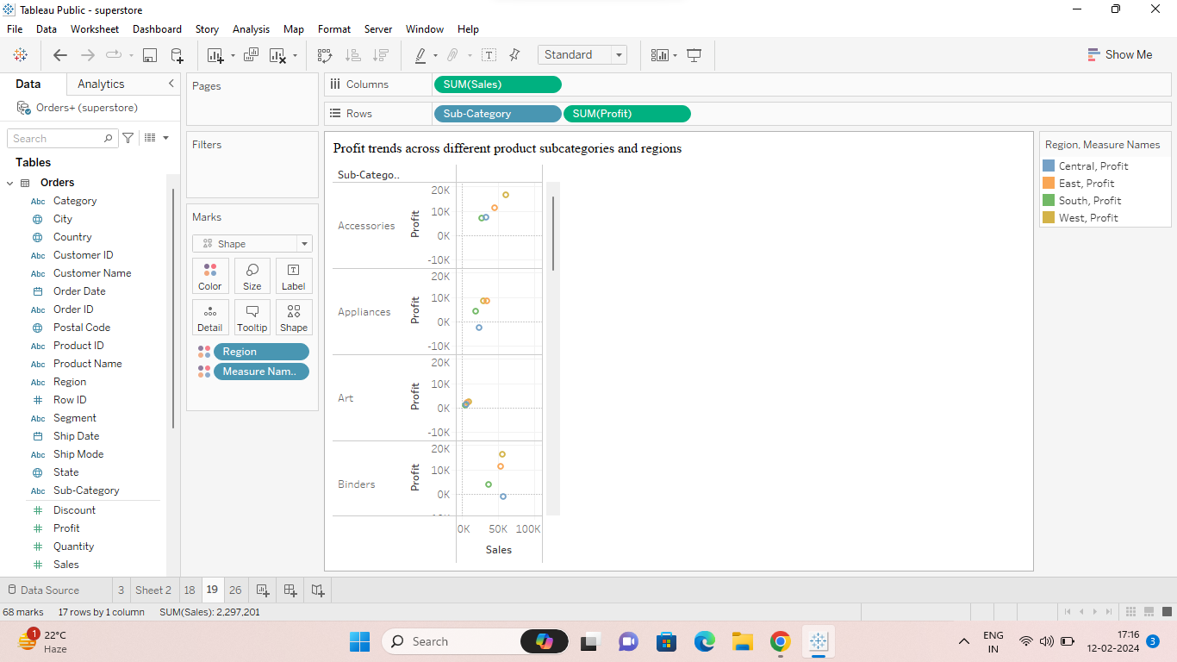

1. What is the average delivery duration for different regions and ship modes?

Ans: Grouped Bar charts are effective for comparing values across different categories, making them suitable for comparing average delivery durations for different regions and ship modes. A grouped bar chart provides a clear separation of different ship modes for each region, making it easy to compare delivery durations side by side.

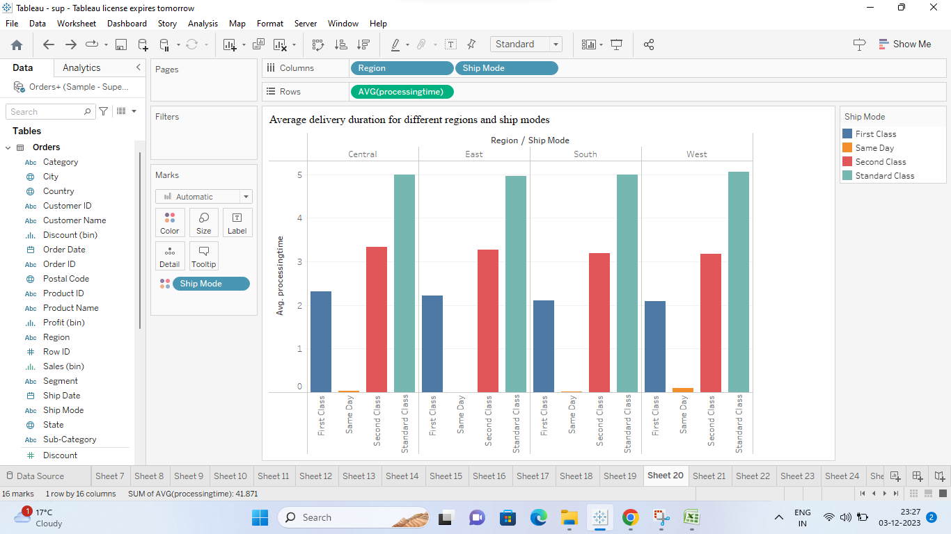

1. How has the average order quantity changed over the years for various product categories?

Ans: Line charts are well-suited for displaying trends over time. Line charts are effective for representing sequential data, where one data point follows another in a logical order. Each product category can be represented by a separate line, allowing for a quick and easy comparison of how the average order quantity changes over the years for each category. Line charts make it easy to identify patterns, outliers, and trends in the data. Any significant increases, decreases, or anomalies in the average order quantity can be visually identified by examining the lines for each product category.

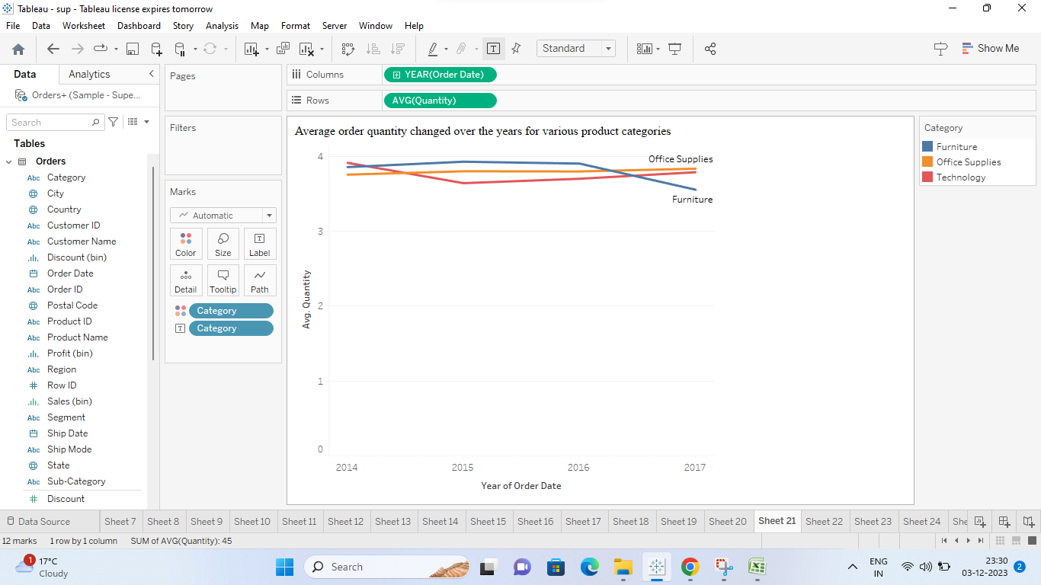

1. Can we visualize the correlation between discount rates and order quantities for different customer segments?

Ans: Scatter plots are excellent for visualizing the correlation or relationship between two continuous variables, such as discount rates and order quantities.Each data point in the scatter plot represents an individual observation, making it easy to see outliers or specific points of interest.

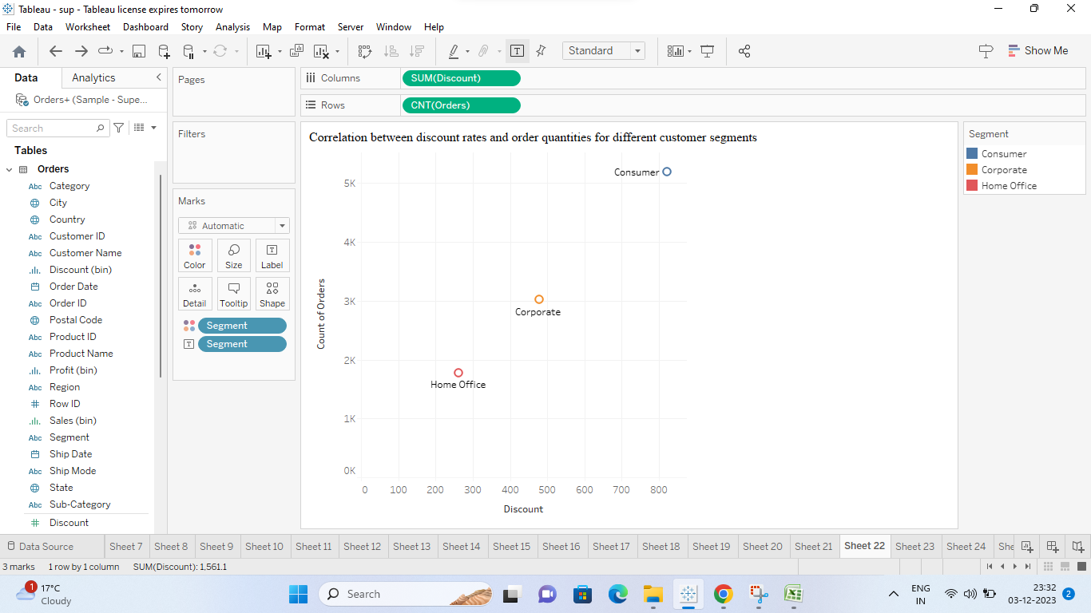

1. What is the proportion of orders returned in each region within the Superstore dataset?

Ans: Column charts are effective for comparing values across different categories. Each column will represent a different region, making it easy to compare the proportion of returned orders across regions. Column charts provide a clear visualization of proportions, as the height of each column is directly proportional to the value it represents. This makes it easy to see which regions have a higher or lower proportion of returned orders.

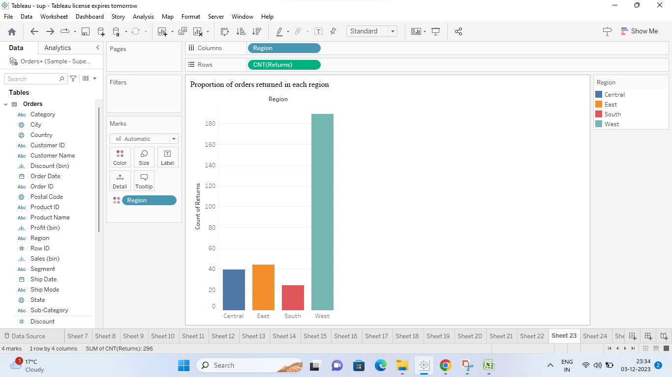

1. How do the sales of high-profit products compare with low-profit products over time?

Ans: Using a scatter plot with sales as the size of the data points, profit as one axis, and product category as the other axis allows for a visual comparison of the sales performance of high-profit and low-profit products across different categories over time. This approach provides a clear and intuitive way to identify trends and patterns in the data and understand how profitability relates to sales within each product category.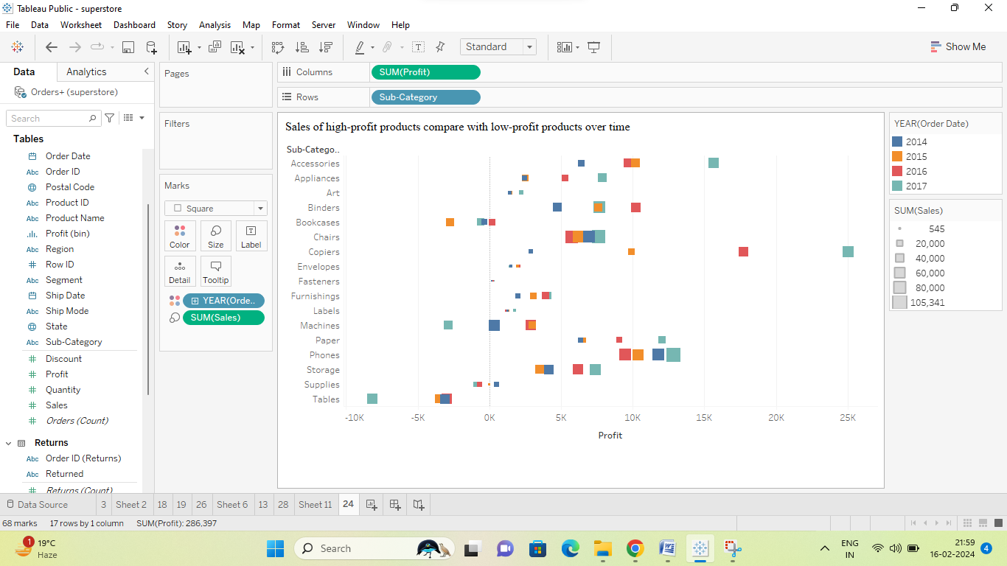

1. Which shipping mode is the most commonly used in the Sample Superstore dataset?

Ans: Using a bubble chart allows us to visualize the popularity of different shipping modes based on the number of orders, with larger bubbles indicating higher usage.

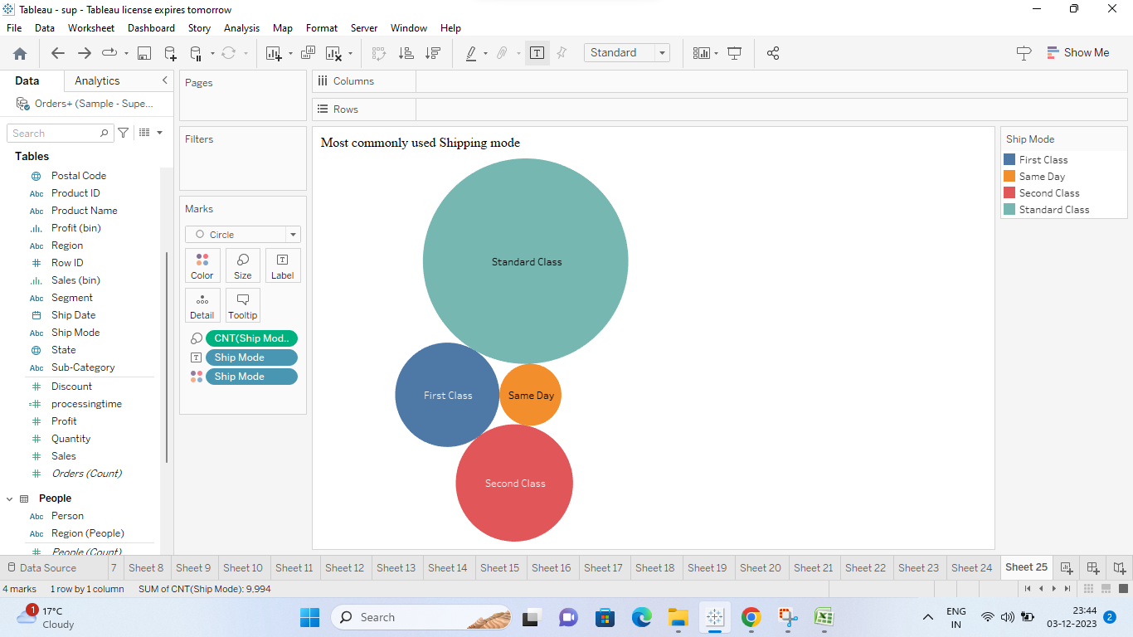

1. How does the sales performance of different regions evolve throughout the quarters of a year?

Ans: Area charts are effective in showing cumulative values, making it easy to see the overall contribution of different regions to the total sales over quarters. Area charts emphasize the overall trend in sales, highlighting how the combined sales of different regions evolve over time. Differentiating regions using color allows for a quick and clear comparison of their contributions throughout the quarters.

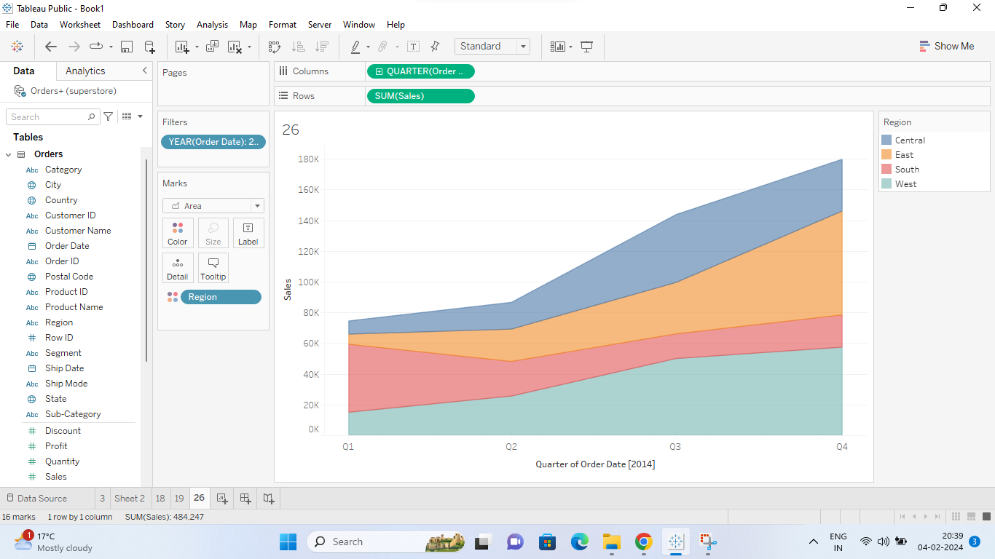

1. What is the distribution of order priorities across different product categories?

Ans: Grouped columns visually differentiate between order priorities, making it easy to compare values side by side within each product category.

Grouped column charts efficiently use space, especially when the number of order priorities is relatively small. Grouped column charts are simple and intuitive, making them accessible to a wide audience.

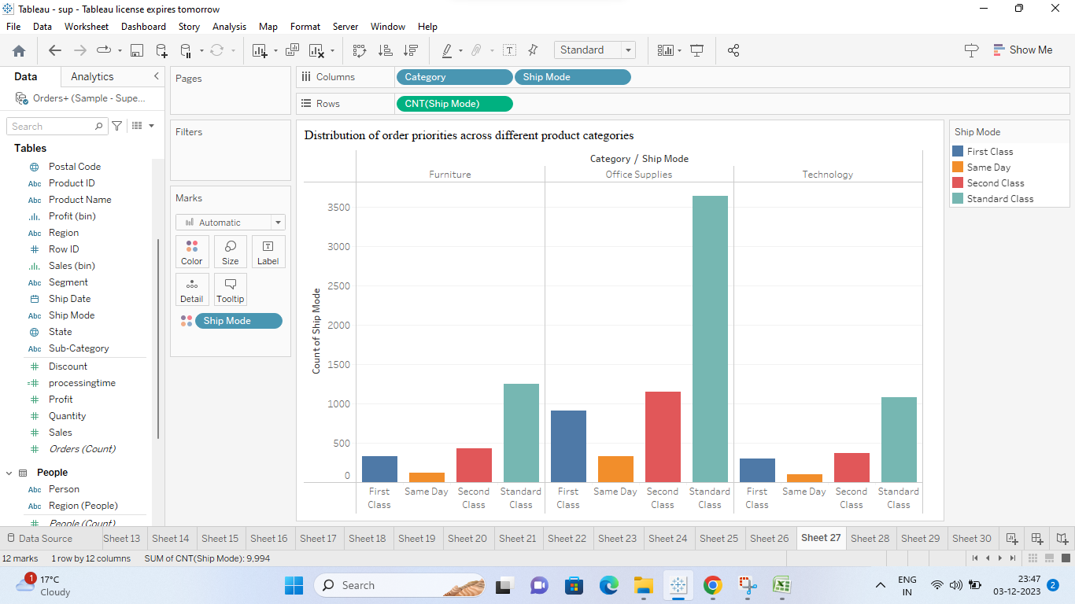

1. What is the relationship between discounts and sales?

Ans: Scatter plots make it easy to identify outliers—data points that deviate significantly from the overall pattern. These outliers may represent unique opportunities or anomalies that warrant further investigation. A scatter plot allows us to observe the correlation between two variables—discounts and sales. By plotting discount rates on one axis and sales on the other, we can visually identify any patterns or trends in the data.

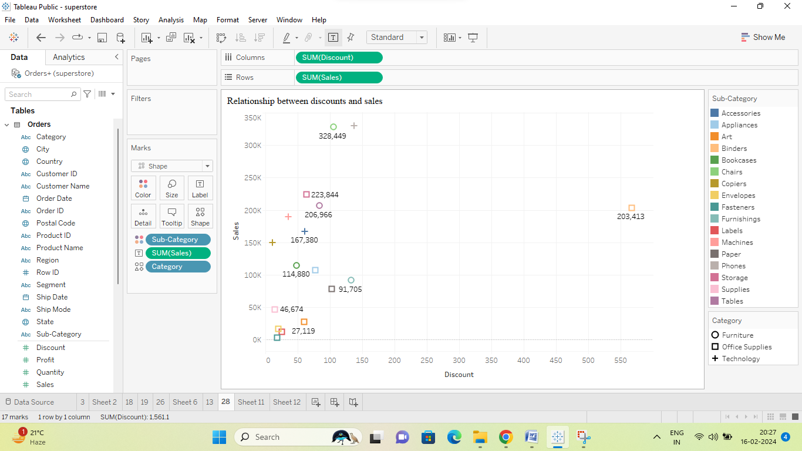

1. How does the average order value differ between repeat customers and new customers?

Ans: Using a bar chart in Tableau to compare the average order value between repeat and new customers provides a straightforward visual representation of any differences in purchasing behavior between these two customer segments. It allows businesses to identify potential areas for improvement in customer retention and acquisition strategies.

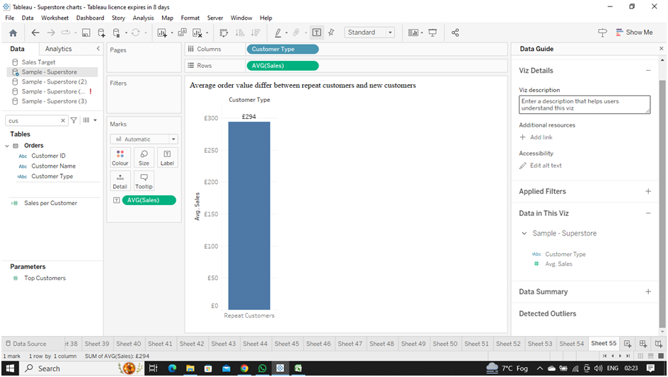

1. What is the geographical distribution of returns and its impact on overall profitability?

Ans: Maps provide an intuitive way to understand geographical data. By visualizing returns and profitability on a map, viewers can quickly grasp where returns are concentrated and how they relate to profitability across different regions. Maps enable easy comparison of returns and profitability across different geographical areas. Color-coding or symbol size can be used to represent the magnitude of returns and profitability, making it straightforward to compare performance between regions.

